Dr Ellie Sweeney Osteopath B.Health Sc, B.App Science (Osteopathy)
Dr Ellie Sweeney has a unique perspective that combines both personal and professional insights into migraines, chronic pain and fatigue management.
Dr Sweeney chose Osteopathy because she believes it provided her with the tools and principles necessary for treating the whole person.
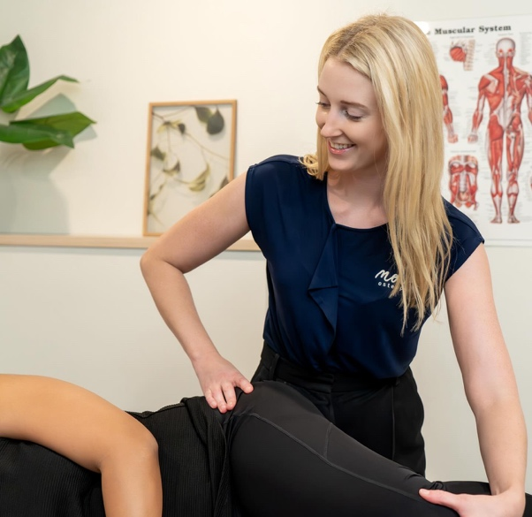
My Story.
My journey with migraines has resulted in a profound interest in sharing the knowledge I've gained as a patient and a practitioner. I am dedicated to providing holistic support to individuals suffering from migraines and myofascial and chronic pain.
I practice the Perrin Technique, a therapeutic approach that enhances lymphatic flow, effectively alleviating fatigue and pain. This technique is particularly beneficial for those coping with chronic conditions and contributes to a comprehensive treatment plan that promotes overall well-being.
In addition to my work as an osteopath, I also teach Pilates.

Eastern Suburbs Osteopathy
Level 6 282-290 Oxford St Bondi Junction (02) 9386 5200

